Experiment 3.4
Cross Correlation
Aim:
To compute and analyze the cross-correlation between two discrete-time sequences using
MATLAB. The Aim is to understand how cross-correlation can be used to measure the
similarity between two signals as a function of the time-lag applied to one of them.
Program:
% Cross Correlation of Two Signals
clc;
clear;
close all;
% Input Signals
x = [1 2 3 4 5];
y = [5 4 3 2 1];
% Cross Correlation
Rxy = xcorr(x,y);
% Lag values
lags = -(length(x)-1):(length(x)-1);
% Display result
disp('Cross Correlation Sequence:');
disp(Rxy);
% Plot
figure;
stem(lags,Rxy,'filled');
grid on;
title('Cross Correlation of Two Signals');
xlabel('Lag');
ylabel('R_{xy}(k)');

Output Waveform:
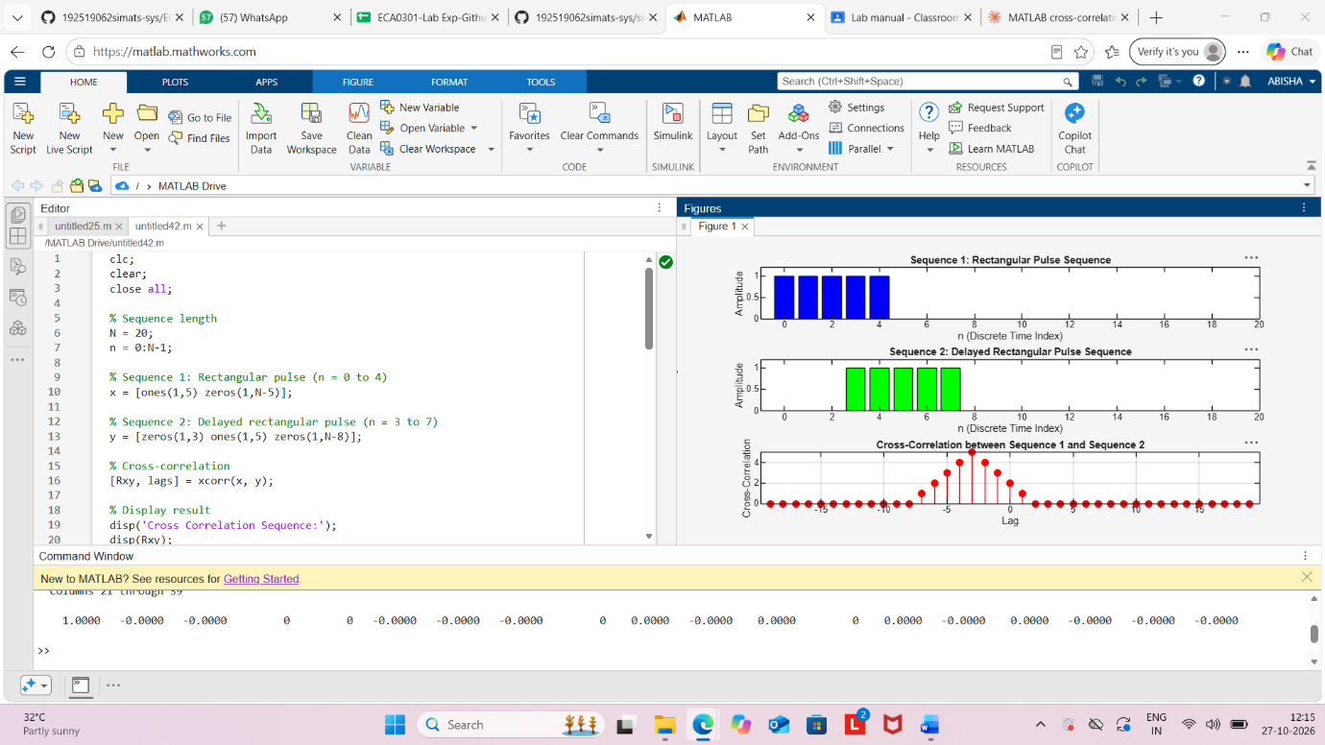

Result:
The cross correlation between the two discrete-time signals was computed successfully using
MATLAB. The resulting sequence indicates the degree of similarity between the signals at
different lag values, helping to identify any time shift or alignment between them.

